Design Pattern Report

Proxy

**Description**

Proxy pattern provides a placeholder, which is representative for an object, to control access to that object.

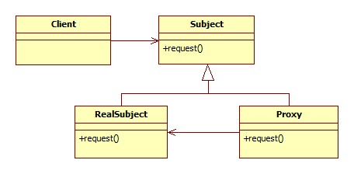

**Example**

RMIT has a local proxy which works as an Internet Service Provider to provide access to RMIT websites for the university’s students. This proxy also records access to resources of each student in order to maintain security.

If there is a connection to external website that is not supported by RMIT Proxy, the proxy will get that website from the real Internet Service Provider.

**Diagram**

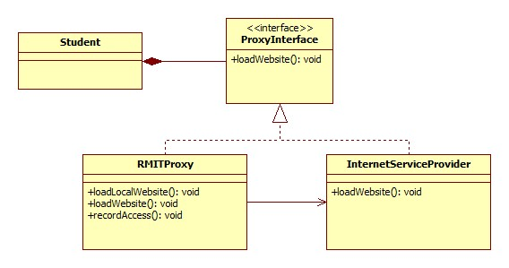

**Advantages**

Proxy pattern is useful when there are difficulties in creating connection to the real object. For example: the connection is delayed, broken or expensive.

The proxy object is customizable, which means users can define their own proxy to meet their requirements.

**Disadvantages**

Domain knowledge is required. In order to construct their own proxy, users are required to understand how the real object works.

Customized proxy and changing access between proxy and the real object could result in complicated source codes.

**Related pattern**

**Alternate pattern/Why it is a better choice**

Strategy pattern ???